Update kit for PT8603 SDI generator
with moving text in patterns

Supplement to: PT 5210 Reference: Manual no. 9499 491 02211
This document describes how to update the PT8603 with moving text in signals and patterns.
The update of PT 8603’s can be divided in two classes:
- one needs an update of 5 programmable parts for adding moving text
- the extended update which also includes update of signal library; this bring the PT8603 up to latest version

Specification for the moving text:
- 3 lines of text, each with a maximum of 32 characters
- Text may either be fixed or moving up and down.
- Text lines can be switch on/off as one group
- Position of text is user programmable
- All above parameters programmable from front plate or via RS232 remote control. below

Parts to be exchanged:
The table below shows part numbers that has to be installed to have full functionality of the PT8603 and the moving text.
 | Position # | Description | Part number | Chksum
Minimum update | V 53 | IC PROM SDI TEST Program  Sw version 3.9 | 4008 002 08041 | 5E9D
Minimum update | V 54 | IC PROG PLD SDI TEST  ADDRESS DECODER | 4008 002 06552 | 9F4C
Minimum update | V 63 | IC PROG PLD SDI TEST  H-COUNTER | 4008 002 06563 | B003
Minimum update | V 75 | IC PROG PLD SDI DATA  MULTIPLEXER | 4008 002 06592 | 8990
Minimum update | V 403 on PT5210 mainboard | IC PROM Master Program  Sw version 3.7 | 4008 002 08031 | A35F
Addtional parts for the extended update | V 64 | IC PROG PROM TEXT PROM | 4008 002 05792 | AC27
Addtional parts for the extended update | V 69 | IC PROG PROM SDI SEGMENT | 4008 002 05804 | 66F0
Addtional parts for the extended update | V 79 | IC PROG PROM P1 SDI TEST | 4008 002 05824 | 4833
Addtional parts for the extended update | V 80 | IC PROG PROM P3 SDI TEST | 4008 002 05834 | B331
Addtional parts for the extended update | V 81 | IC PROG PROM P2 SDI TEST | 4008 002 05844 | 09FA

Installation of firmware on PT5210 mainboard

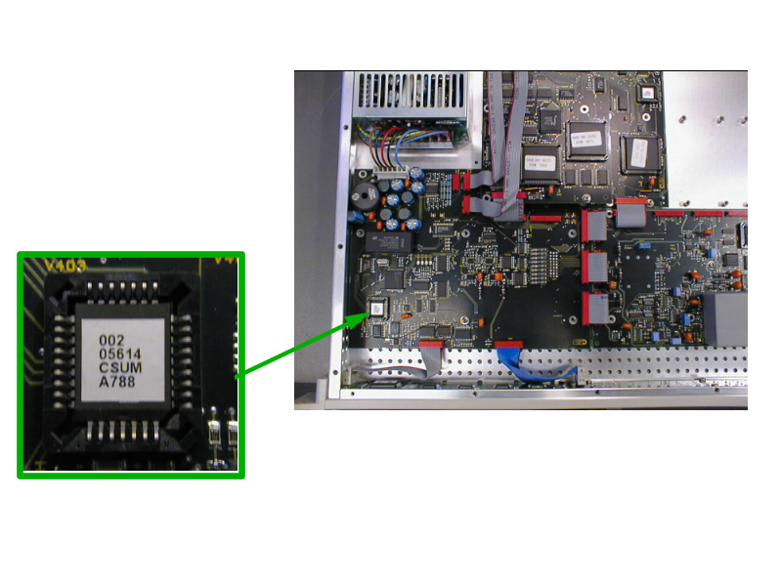
Picture 1: The positioning of the master processor PROM. The lower right corner on the PROM is indicated by a cut in the chip. (Note, that code number on actual PROM may differ from Photo)
Mount the PROM with the above number and identification.

Installation of firmware on PT 8603 generator board

Her indsættes tegning eller foto

Picture 2 The positioning of the PROMs and PLDs on the PT8603.
Mount the parts according to the list above. For newer versions of the PT8603 only the 4 first parts have to be exchanged.
(Note, that code number on actual PROMs and PLDs may differ from Photo)

After the installation has been made, make a “Master Reset” of the instrument:
Keep left and right key buttons pressed while switching power on.

Menu description
Now an extended menu structure is available for the PT8603
Please refer to page 6-23 in the User’s manual for the preceding menus.

To change the text inserted in the test pattern, select TEXT.
SUBMNU:SDI-SIGNAL/TEXT, edit text E
USER-TEXT:< > On SAVE ESC

Skal rettes !!!!!!!!!!!!!!!!!!

SUBMNU:SDI-SIGNAL/TEXT, edit text E
USER-TEXT:< > Off SAVE ESC

Operation:
- To start the editor, select the TEXT field and press EXECUTE
- Use the  and  buttons to select the character position
- Scroll through the characters with the  and  buttons. The character being edited will flash during the editing process
- To exit the editor, press EXECUTE
- The text string can be turned on or off by using the û and ú buttons to select ON/OFF
- When the desired selection appears in the display, move the cursor to SAVE and press EXECUTE
- If no change is desired, move the cursor to ESC and press 
Leaving the function takes you back to the SDI-SIGNAL menu.

Note:

Selecting OFF does not clear the text string setting.

Text insertion options:
- 3 text lines can be added, user programmable. Text lines can be switched ON/OFF collectively
- Maximum 32 UPPER-case characters can be inserted per line
- Characters available: A-Z, 0-9, -, _, and space
- Text can be positioned across the screen in one text line height and in one characters width
- Text lines can be set into a scroll mode, scrolling ? lines up and down.

Remote commands.
The commands available via RS232C have been extended to include the extended functionality.

In the OUTPut Subsystem the following has been added:
(The full string to be sent is listed)

Input oftext
:OUTP:SDIS:TEXT:STRING1 'XYZ'; (for line 1) or
:OUTP:SDIS:TEXT:STR1 'XYZ'; and
:OUTP:SDIS:TEXT:STRING1?; for query

Activating text ON/OFF and setting MOVEMENT
:OUTP:SDIS:TEXT:ONOFF ON; to set text on and
:OUTP:SDIS:TEXT:ONOFF OFF; to set text off
:OUTP:SDIS:TEXT:ONOFF?; to query text on/off

:OUTP:SDIS:TEXT:MOTION ON; to set text motion on or
:OUTP:SDIS:TEXT:MOT ON; and
:OUTP:SDIS:TEXT:MOTION OFF; to set text motion off
:OUTP:SDIS:TEXT:MOTION?; to query text motion

Setting of text position
:OUTP:SDIS:TEXT:POS 3,3; to set text position or
:OUTP:SDIS:TEXT:POSOSITION 3,3;
:OUTP:SDIS:TEXT:POS?; to query text position

NOTE:
Command for :OUTP:SDIS?; (query) does not output any text parameters due to the extended length of returned data

